What is KNN (K-Nearest Neighbor) Algorithm

The K-Nearest Neighbor (KNN) algorithm is a popular machine learning technique used for classification.

it calculates the distance between the input data point and all the training examples, using a chosen distance metric such as Euclidean distance.

Next, the algorithm identifies the K nearest neighbors to the input data point based on their distances.

The KNN algorithm is straightforward and easy to understand

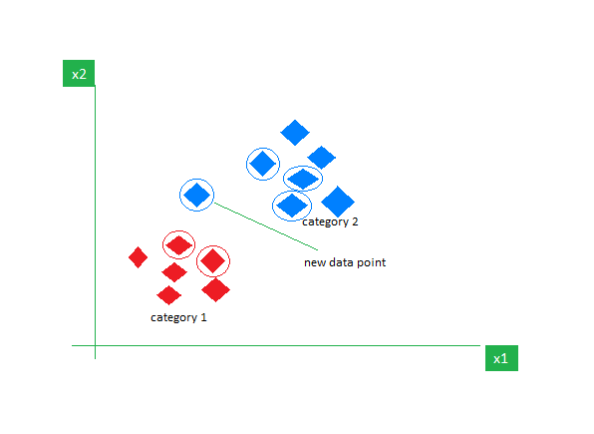

## Distance Metrics Used in KNN Algorithm

1. Euclidean Distance
2. Manhattan Distance
3. Minkowski Distance

## Advantages of the KNN Algorithm

* **Easy to implement** as the complexity of the algorithm is not that high.
* **Adapts Easily**
* **Few Hyperparameters**

## Disadvantages of the KNN Algorithm

* **Does not scale** – As we have heard about this that the KNN algorithm is also considered a Lazy Algorithm.
* The main significance of this term is that this takes lots of computing power as well as data storage.

1. Minkowski Distance